RAI AZMAT TARIQ

465039

SEC A

ASSIGNMENT 1

Q1.

#include<iostream>

using namespace std;

int main()

{

int x,y;

cout<<"Enter any positive integer: ";

cin>>x;

for(y=1;y<=x;y++) {

if(x%y==0) {

cout<<z<<":"<<endl;

}

} cout<<"These are the factors of given integer";

return 0;

}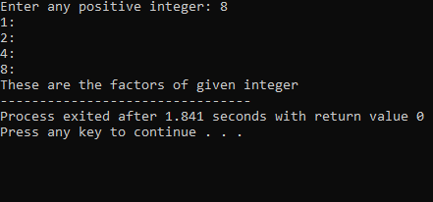

Q2.

X is 5 y is 10

Q3.

#include<iostream>

using namespace std;

int main()

{

int x;

bool z;

cout<<"Enter any integer: ";

cin>>x;

z=(x>10 && x<=20);

cout<<"Answer: "<<z<<endl;

return 0;

}

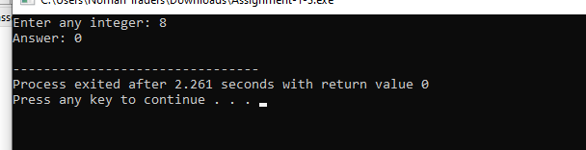

Q4.

#include <iostream>

bool isPrime(int n) {

if (n <= 1) {

return false;

}

for (int i = 2; i \* i <= n; ++i) {

if (n % i == 0) {

return false;

}

}

return true;

}

int main() {

int N;

std::cout << "Enter a positive integer N: ";

std::cin >> N;

if (N <= 1) {

std::cout << "No prime number less than or equal to " << N << std::endl;

return 0;

}

int largestPrime = N - 1;

while (largestPrime > 1) {

if (isPrime(largestPrime)) {

break;

}

--largestPrime;

}

std::cout << "The largest prime number less than or equal to " << N << " is: " << largestPrime << std::endl;

return 0;

}

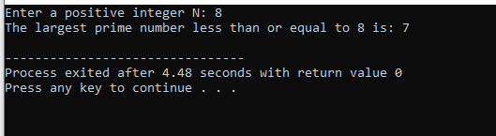

Q5.

#include<iostream>

#include<algorithm>

using namespace std;

int main() {

string s1;

string s2;

cout<<"Enter the first string: ";

cin>>s1;

cout<<"Enter the second string: ";

cin>>s2;

if(s1==s2){

rotate(s2.begin(), s2.begin()+1, s2.end());

cout<<"After rotation: "<<s2;

}

else {

cout<<"The strings are unequal";

}

return 0;

}

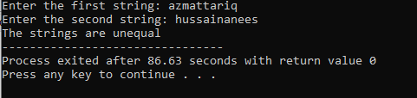

Q6.

#include<iostream>

using namespace std;

int main() {

int x,y,z(0);

cout<<"Enter the divisor: ";

cin>>y;

cout<<"Enter the dividend: ";

cin>>x;

if(x>y){

while(x>=y){

x-=y;

z++;

}

cout<<"Answer: "<<z;

}

else

cout<<"Divisor is greater than dividend";

return 0;

}

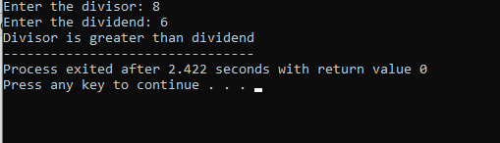

Q8.

#include<iostream>

using namespace std;

int main(){

int a[5]={1,2,3,4,5};

int x=5;

int ele[]={6,7,8,9,10};

int y=10;

cout<<"The new array is: ";

for(int i=0;i<y;i++){

if(i<x) {

cout<<a[i]<<" ";

}

else{

cout<<ele[i-x]<<" ";

}

}

cout<<endl;

return 0;

}

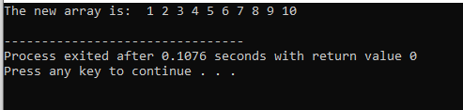

Q9.

#include<iostream>

using namespace std;

int main() {

int ary[10]={1,2,3,4,5,6,7,8,9,10};

int x;

cout<<"Enter the values: ";

cin>>x;

for(int i=0;i<=10;i++) {

for(int j=0;j<=10;j++) {

for(int y=0;y<=10;y++) {

if(ary[i]+ary[j]+ary[y]==x){

cout<<ary[i]<<" "<<ary[j]<<" "<<ary[y]<<endl;

}

}

}

} return 0;

}

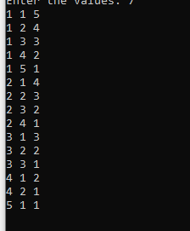

Q10.

#include<iostream>

using namespace std;

int main()

{

int n,a[n];

cout<<"Enter the value of n:";

cin>>n;

int x;

for(int i=0;i<n;i++)

{

cin>>a[i];

}

for(int i=0;i<n;i++)

{

for(int j=0;j<n-1;j++)

{

for(int k=j;k<=j+1;k++)

{

if(a[j]>a[k])

{

x=a[j];

a[j]=a[k];

a[k]=x;

}

}

}

}

for(int m=0;m<n;m++)

{

cout<<a[m]<<" ";

}

return 0;

}

